**Practical 15:**

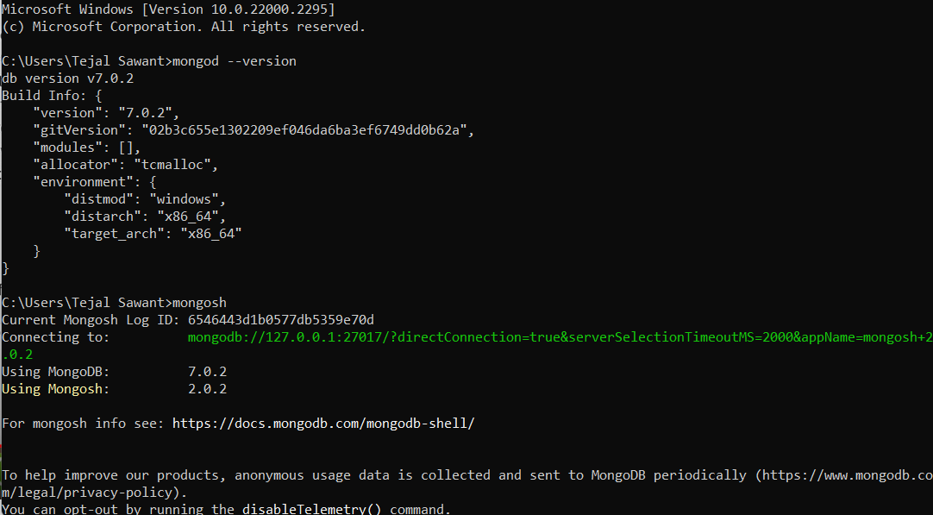

show dbs

use book

show collections;

db.createCollection("library");

db.library.insert({"bid":1,"name":"C++"});

db.library.insert({"bid":2,"name":"SEPM","author":"Pressman"});

db.library.insert({"bid":3,"name":"CN","author":"Forouzan","cost":700});

db.library.find().pretty();

db.library.remove({"bid":1});

db.library.count();

db.library.find().pretty();

db.library.insert({"bid":1,"name":"C++"});

db.library.find().pretty();

db.library.find().sort({"bid":1})

db.library.insert({"bid":4,"name":"SPOS","author":"Pearson","cost":500});

db.library.find().pretty();

db.library.find().sort({"bid":1})

db.library.find({$and:[{"name":"CN"},{"cost":700}]}).pretty()

db.library.insert({"bid":5,"name":"TOC","author":"Addison-Wesley","cost":600});

db.library.insert({"bid":6,"name":"AI","author":"McGraw Hill Education","cost":800});

db.library.find().pretty();

db.library.find({$or:[{"cost":500},{"cost":800}]}).pretty()

db.library.find({"cost":{$ne:500}})

db.library.find({$nor:[{"cost":500},{"author":"Forouzan"}]})

db.library.find({"cost":{$not:{$gt:800}}})

db.library.insert({"bid":7,"name":"CC","author":"Wiley Publications","cost":400})

db.library.find()

db.library.update({'cost':400},{$set:{'cost':600}})

db.library.update({'cost':800},{$set:{'cost':1200}})

db.library.find().pretty();